**Bus Reservation System**

**A PROJECT REPORT**

**Submitted by**

**Muhammad Umar**

*in whole fulfillment for the award of the degree*

*of*

**BS**

*in*

**Computer Sciences**



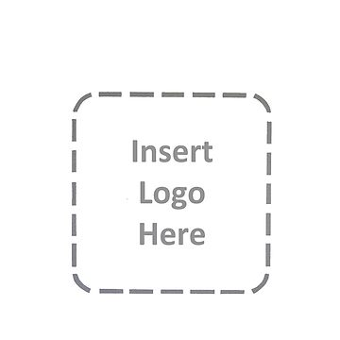

**Riphah Institute of Computing & Applied Sciences**

**Riphah International University Lahore**

**JAN 2021**

i

**CERTIFICATE**

**Certified that this project report “Bus Reservation System” is the bonafide work of “Muhammad Umar” who carried out the project work under my supervision.**

|  |  |  |
| --- | --- | --- |
| **Rana Marwat Hussain**  Lab Instructor | **Mr. Fahd**  HOD | **Mr. Fawaad**  Lecturer |

**Riphah Institute of Computing & Applied Sciences**

**Riphah International University Lahore**

ii

**ACKNOWLEDGEMENT**

I would like to express my special thanks of gratitude to my project guide **Rana Marwat Hussain** as well as our Lecturer **Mr. Muhammad Fawaad** who gave me the golden opportunity to do this wonderful project on the topic **Bus Reservation System**, which also helped me in doing a lot of research and I came to know about so many new things I am really thankful to them.

Secondly I would also like to thank friends who helped me a lot in finalizing this project within the limited time frame.

|  |  |
| --- | --- |
| Date : **January 15, 2021** | Student: **Muhammad Umar** |
| Place : **Faisalabad** | SAP ID: **15024** |
|  | Class: **Sem. 3, Sec A** |

iii

**TABLE OF CONTENTS**

|  |  |  |
| --- | --- | --- |
|  | **TITLE** | **I** |
|  | **CERTIFICATE** | **ii** |
|  | **ACKNOWLEDGMENT** | **iii** |
|  | **TABLE OF CONTENTS** | **vi** |
|  | **ABSTRACT** | **vii** |
| **1.0** | **INTRODUCTION** | **1** |
|  | 1.1 Employee’s Module | 1 |
|  | 1.2 Passenger’s Module | 2 |
|  | 1.3 Use-case Diagram | 3 |
| **2.0** | **LITERATURE REVIEW** | **4** |
|  | 2.1 Study on Electronic Ticketing in Public Transport | 4 |
|  | 2.2 Online Transport Booking System | 4 |
| **3.0** | **METHODOLOGY** | **5** |
| **4.0** | **EXPERIMENTATION** | **6** |
|  | 4.1 Explanation | 4 |
|  | 4.2 Gantt Chart | 4 |
| **5.0** | **RESULT AND DISCUSSION** | **7** |
| **6.0** | **CONCLUSION** | **11** |
| **7.0** | **FUTURE SCOPE** | **12** |
|  | **REFERENCES** | **13** |

iv

**ABSTRACT**

This is project report of my work that I have done. My project is to make a Bus Reservation System. This report contains every piece of information regarding my project. Every assumption, conclusion, methodology, review, and all the required information clearly exists in this project report. The scope of my project is also defined here.

Life is much difficult for Passenger without Digital Bus Reservation System. Bus Reservation System is designed to overcome the problem of queue up. This makes the Passenger capable to book ticket in advance i.e. before travel when desired. This System make work of Passenger and client easy. So basically Bus Reservation is the system in which whole work become digitalized for both admin/client and passengers. Passenger can pay fare digitally. Admin can monitor and manages whole system digitally.

This project presents a review of the software program "Online Bus Ticket Reservation System" as should be used in a bus transportation system. Using this program, the user can easily reserve a seat on any bus according to the desired time in advance. Users can check available buses and also check the required details of buses. Moreover, with the bus ticket reservation system, you can manage reservations and client data. Users can also schedule journey routes, set seat availability, and select their seats.

v

1. **INTRODUCTION**

Today, the world has made great strides in the field of science and technology. Everything turned smart and fast for the ease of human being. Science has changed everything. In this way, the Digital Bus Reservation System overcome the traditional ticket & booking system. This modern convenience is more beneficial, as the record-keeping process become easier & moreover it saves time.

So I have created a program for Bus Reservation System. My project works for 2 entities. First entity is Employee and other one is Passenger. Both have different authorities. Employee can manage the whole bus system i.e. insert record of new bus, delete record of any existing bus, update record if needed and check the seat status of any bus.

On the other hand, Passenger can reserve ticket in bus of desired city. Passenger can check all available buses and also check Bus of Specific city.

**1.1 Employee’s Module**

1. **Install Bus Information**

This feature allows only employee to install a typical bus information before it can be reserved by the passengers or shown in buses available section. It includes the bus no., driver’s name, arrival time, departure time, sources city (from), destination city (to), fare of bus and also the class of the bus.

1. **Show Available Buses**

This feature simply shows the buses available for reservation. Information shown is that, which is stored and updated by employee. Reserve seat status is also shown along all information stored via Install Bus Information. This feature is for both employee and passenger. Both entities can used this feature.

1. **Update Bus Record**

This feature allow employee to make change in any bus information. Changes made on the basis of bus no. which can’t be changed. All information can be changed easily.

1. **Delete Bus Record**

This feature allow employee to delete record of any bus information. Record is deleted on the basis of bus no. Reason behind the deletion may old bus or any other.

**1.2 Passenger's Module**

1. **Show Available Buses**

This feature simply shows the buses available for reservation. Information shown is that, which is stored and updated by employee. Reserve seat status is also shown along all information stored via Install Bus Information. This feature is for both employee and passenger. Both entities can used this feature.

1. **Reserve Bus Seat**

This feature is specifically for Passenger. Passenger can reserve seats, no matter how many. This reserved seats automatically updated in system instantly. If limit i.e. 36 exceed, system tells situation and suggest solution.

1. **Show Specific Bus Detail**

This feature is also for Passenger use. Bus detail of specific city can be checked easily. Main purpose for use of this feature is to check reserve seats by passenger. This also updated timely.

**1.3 Use case diagram:**

**Passenger**

**System**

**Employee**

Install Buses

Supervise System

Reserve Ticket

Bus

Reservation

System

All Buses Information

Manage System

Edit

Information

Show Specific bus

1. **LITERATURE REVIEW**

According to Kevin (2012) Web-based Bus Reservation and Ticketing System is a generic web portal application that aids bus customers to reserve a seat in a certain bus company anytime and anywhere and variety of buses that satisfy the customer’s requirements. The project, on the bus company’s side, serves as a marketing strategy and aids an efficient processing and delivery of itinerary receipts.

**2.1 Study on Electronic Ticketing in Public Transport**

A consultant with European Metropolitan Transport Authority (EMTA), Mohamed Mezghani (2008) stated that EMTA has established a working group to work on the issue of electronic ticketing. This group is mandated to generate knowledge, exchange/compile information and learn from the experience of its members in the field of electronic ticketing. In his framework, EMTA has launched a study on electronic ticketing in public transport under the supervision of the working group and they designed certain concepts such as the public transport pricing, public transport ticketing and electronic ticketing in public transport.

On the contrary, his research which discussed certain concepts in relation to electronic ticketing in public transport was a one-directional article which didn’t relate the idea about customer reserving seats and for their journey at a date chosen by them.

mentioned as well as display certain screenshots of the customers’ reservations system.

**2.2 Online Transport Booking System**

Badariah, (2007) emphasized that the Online Transport Booking System which was developed at Politeknik Kota Kuala Terengganu (PKKT) was to make sure that users could make their online booking or reservations to their desired transport companies with facilities provided by the new system. He pointed out that the methodology a technology being used in this new transport system could be applied to other areas of activities. The user who wants to use the transport must make an application to book the transport before boarding.

This project will also enlighten prospective customers and users of the system on the need to patronize the system as it displays more advantages over the old system by providing an easy to use Graphic User interface (GUI) interaction, checking availability of routes before boarding etc.

1. **METHODOLOGY**

In order to creating Bus Reservation System, first I check different digital ticket reservation systems. I thoroughly check systems and their functionalities. I check; How they working? How they programmed? What features they have? What more features should inserted? And all the things that can possibly make my reservation system more effective and efficient. For both entities i.e. Employee and Passenger. All the important things that may help me in programming, moreover I noted and examine that how my system look like with this change. In this way, I collected desired data from different existing systems.

Methodology includes process flow i.e. SDLC explanation. SDLC must follow in order to design effective software or program.

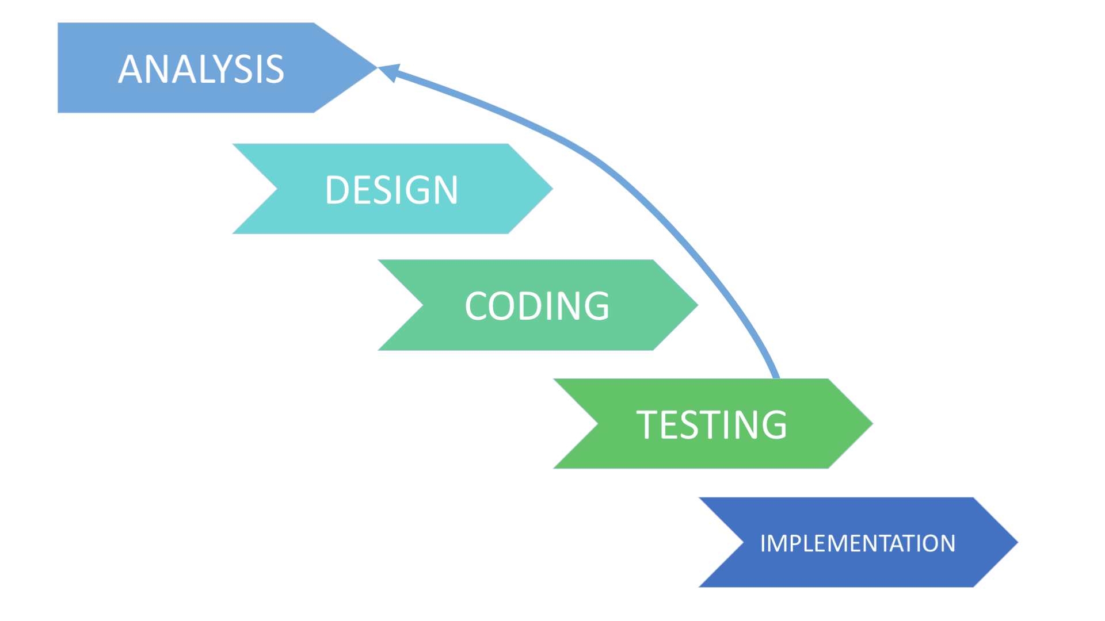

Figure 3.1: General Methodology

1. **EXPERIMENTATION**

**4.1 Explanation:**

While developing a code there are different problems I’ve experienced. These problems were overcome by making proper research on them. Some of problem were error which may syntax, logical and compilation, on the other side, it may conceptual problem. Any concept which remained unclear in lectures, clears as there practical use done here. Use of classes and constructors become easy in C++. Proper use of string also learned while working on project. Linked List is the basic concept and data structure used in this program. It became easier for me as its use have been done in project at vast level.

**4.2 Gantt chart:**

This project will comprise all the activities involved in SDLC (see Fig 1). All these activities have been summarized in a Gantt chart below.

|  |  |  |  |  |  |  |  |  |  |  |  |  |  |  |
| --- | --- | --- | --- | --- | --- | --- | --- | --- | --- | --- | --- | --- | --- | --- |
| Weeks activity | 1 | 2 | 3 | 4 | 5 | 6 | 7 | 8 | 9 | 10 | 11 | 12 | 13 | 14 |
| Problem  Definition |  |  |  |  |  |  |  |  |  |  |  |  |  |  |
| Requirement  Identification |  |  |  |  |  |  |  |  |  |  |  |  |  |  |
| Analysis |  |  |  |  |  |  |  |  |  |  |  |  |  |  |
| Design |  |  |  |  |  |  |  |  |  |  |  |  |  |  |
| Implementation testing documenting |  |  |  |  |  |  |  |  |  |  |  |  |  |  |

1. **RESULT AND DISCUSSION**

Bus Reservation System will reduce unnecessary costs and time consumption. The problems associated with the current system will be addressed with the new proposed system. The whole design of the proposed system is a clear automation of the current system at Modern coast bus ticket booking system and therefore the problems associated with the manual system are well addressed by this design.

Despite a few challenges in the implementation process, the process was a successful one as I was able to make a system that did not only work but also got acceptance form users. Taking this project all through has been a wonderful experience for me and for the practical knowledge that I acquired. This is a very important part of my course and has helped me in order to understand the concepts behind a number of web scripting languages as well as familiarize with the market expectations of the course at large.

Some Output Screenshot are given there:

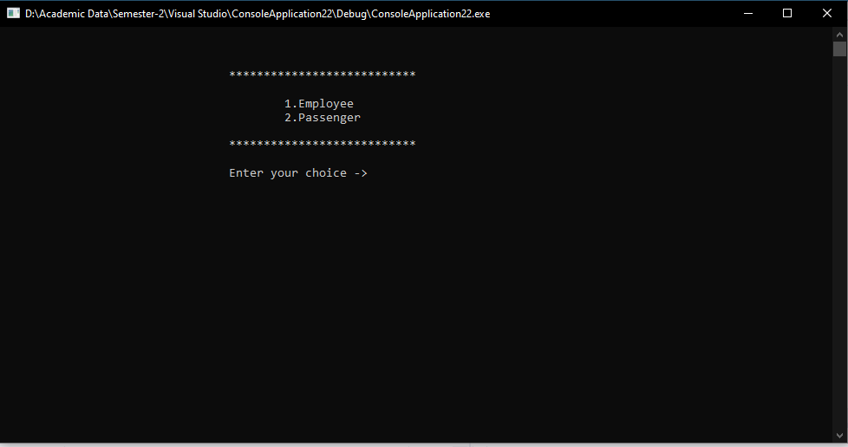

Fig.5.1 Main menu

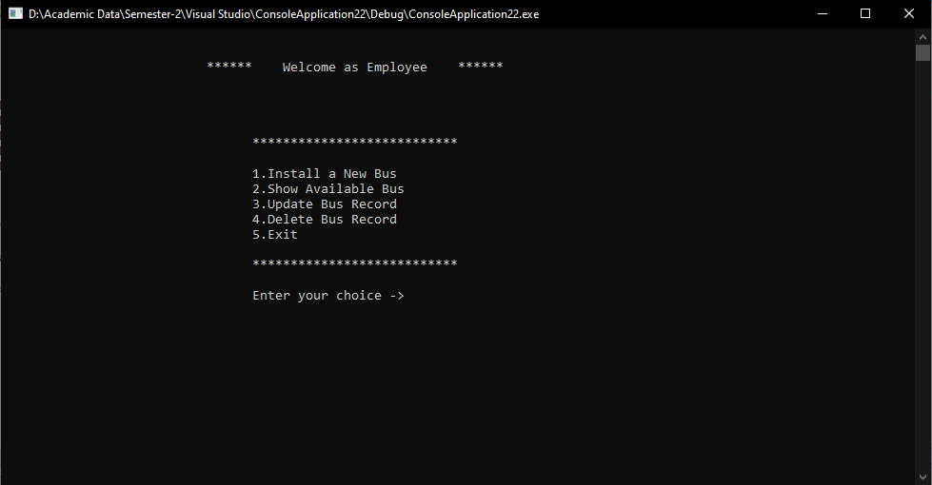

Fig. 5.2 Menu for employee

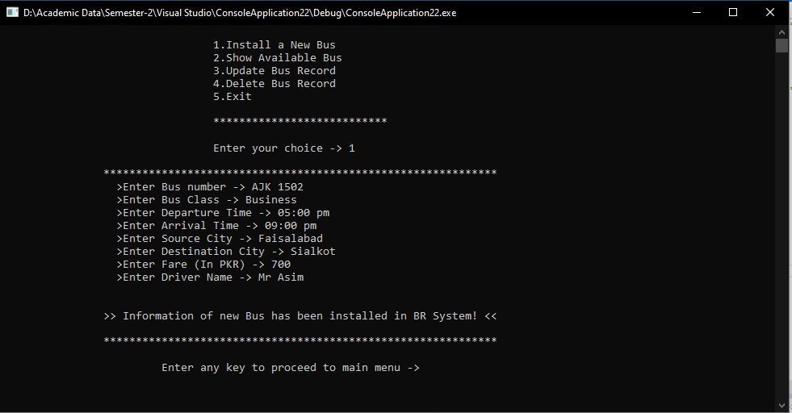

Fig.5.3 Install a Bus

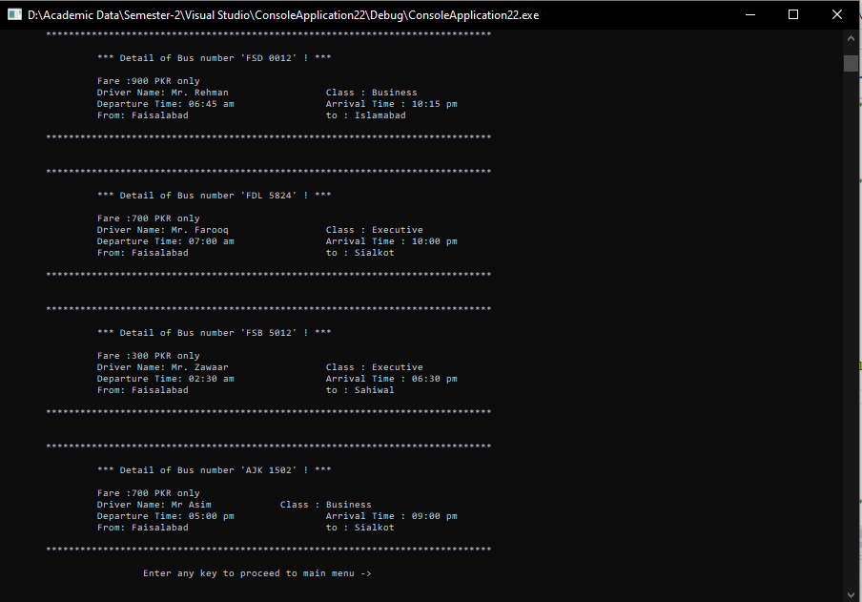

Fig. 5.4 Details of Buses

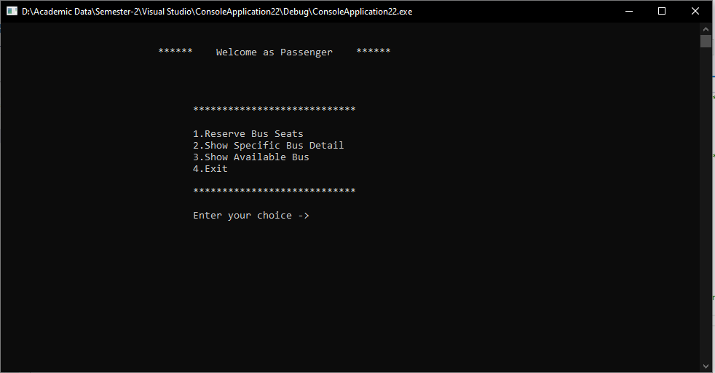

Fig. 5.5 Menu for Passenger

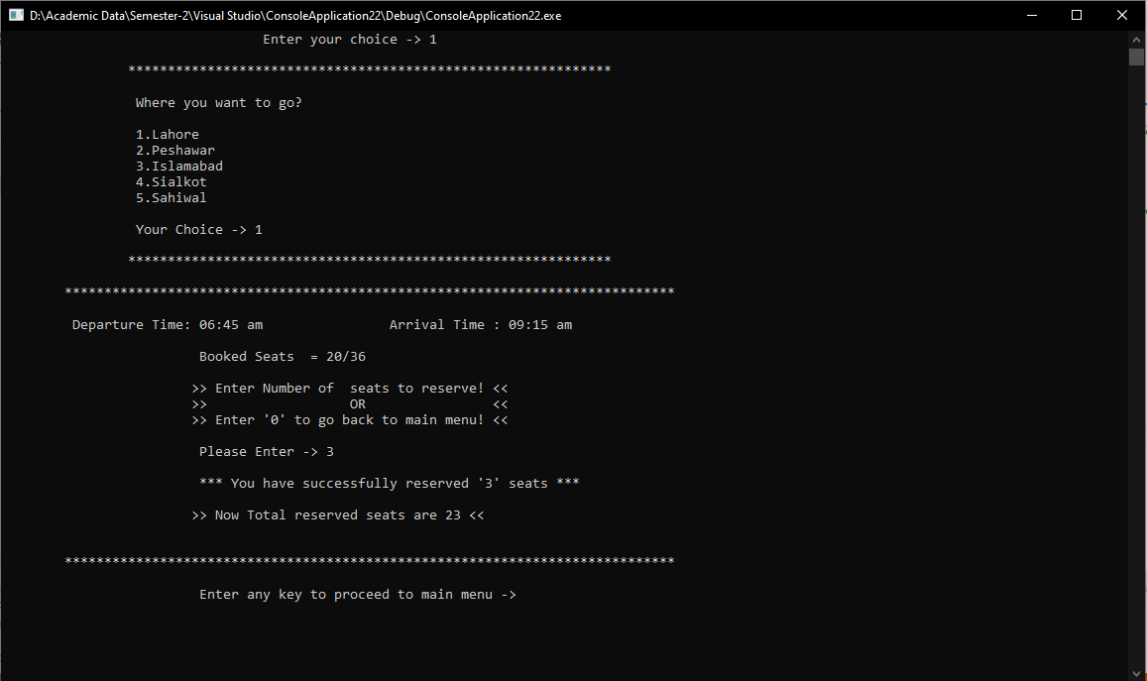

Fig. 5.6 Reserve Seats

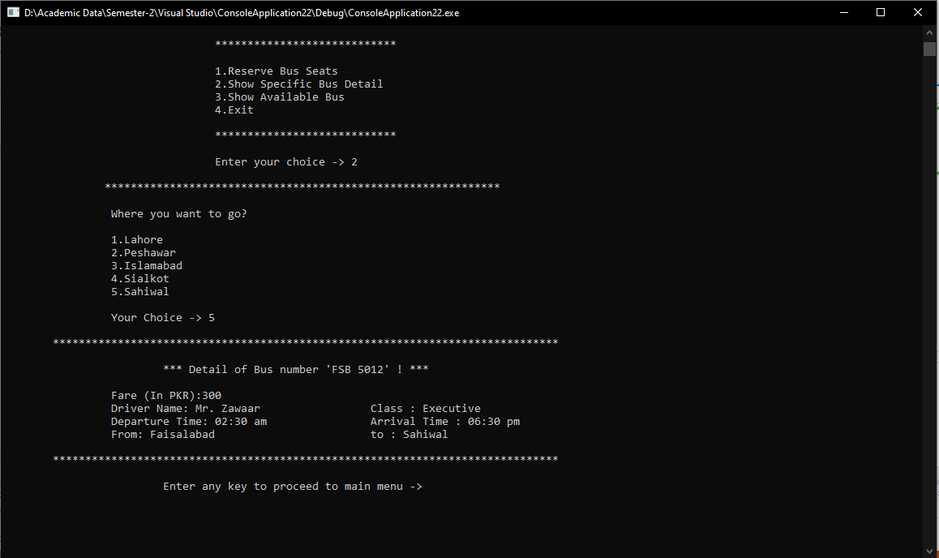

Fig. 5.7 Check Specific Bus

1. **CONCLUSION**

Difficulties encountered with the manual system are overcome in this system. It can be observed that computer applications are very important in every field of human life. Here all the information about customer that made reservation can be checked just in a second with this reservation system. It will also reduce the human effort, reduce the time used for making reservation at the bus terminal and also increase efficiency. The application also has the ability to update bus records in various files automatically and relieving the company’s staff the stress of working from file security of data.

This project, as a whole, will give a new way in bus reservations and ticketing processes. The automation and management of seats and reservations will be done here. This also lessens the papers work for data collection like in the traditional way of ticketing.

With the passage of time, I’ll try to update my program code by introducing new features according to the user requirements that can make the journey more comfortable. We’ll upgrade the code timely make it secure and bug-free.

1. **FUTURE SCOPE**

Things can’t be perfect. It’s means that updates are also required in any system with increase experience. With the passage of time, I’ll try to update my program code by introducing new features according to the user requirements that can make the journey more comfortable. This is just a web based application. We’ll upgrade the code timely make it secure and bug-free. Its interface can also be enhance to make it more attractive and interactive also. I would like to say that my system did not capture everything that would be required and would therefore recommend for future improvements on the following:

* Feature to allow the admin message the clients within the system.
* Features to enable clients give their feedback and suggestions.
* Feature of online payment
* Introducing mobile application.
* Feature of customer care.

**REFERENCES**

1. ResearchGate.net
2. Academia.edu
3. Quora.com
4. StackOverflow.com
5. Tutorialspoint.com
6. W3schools.com
7. Geeksforgeeks.org
8. Google.com
9. Youtube.com